5216 Project Proposal

目录

Abstract 1

Introduction 1

Objective 2

Related Work 2

①Google Keep 2

②Evernote 2

③Any.DO 2

④Todoist 3

App Storyboard 3

①Main Interface – layout 1 3

②Deleting Interface – layout 2 7

③Editing Interface - layout 3 7

④Map Interface – layout 4 8

Reference 8

# Abstract

The purpose of this project is to build a notes-taking app. This project proposal aims to clarify the idea and set the schedule. It consists of five sections: Introduction, Objective, Related Work, App Storyboard and Schedule. In the Introduction and Objective, the motivation of this project and the purpose of the final app will be discussed. Pros and cons of five famous notes-taking app will be covered in Related Work. Also, the storyboard of the final app will be explained in detail in App Storyboard. In the end, the schedule of this project will be displayed.

# Introduction

Nowadays, taking notes on the smart phone is essential in people’s daily life. There are also many useful notes-taking apps such as Google Keep, Evernote, Any.DO and Todoist, developed for Android to help people memory things easily. However, all of these apps have a significant problem that when the number of notes grow to hundreds or thousands, it is really difficult to find the note that the user exactly wants. To solve this problem, this project will try to build one new Android app to help people taking notes.

# Objective

This project aims to help users finding necessary notes with both passive and active ways. For passive way, users can find a specific note with a sequence of distance, date and so on. The final app will also allow users to search notes with keywords. For active ways, the final app will also remind users the notes automatically according to the user-setting position, date and so on.

# Related Work

To determine whether this project is valuable, four notes-taking app developed for Android is compared with the objective of the final app. Those four apps are Google Keep, Evernote, Any.DO and Todoist.

## ①Google Keep

## ②Evernote

## ③Any.DO

Any.DO is one of the most famous notes-taking app which was launched on Android in November 2011. [1] After getting into the app, the list of notes will be displayed. However, only the excerpt of each note is displayed on the screen. The final app of this project will also show the location and reminding time. After clicking on the notes, the reminding time will be displayed. There is no search box in the main interface. The users can only sequence the notes with date and priority. Users should pay for the location reminder service.

## ④Todoist

Todoist is also very famous among notes-taking app users. [2] The date and excerpt of each note is displayed in the list in the main interface. There is a search button in the top right of the main interface. Users can sort the notes by date, priority and name. However, this app can not link the note with the location. All of reminders are not free. The final app of this project will actively remind users things based on positions for free.

# App Storyboard

The final app will contain 4 layouts. In this section, all of the four layouts will be explained separately in detail.

## ①Main Interface – layout 1

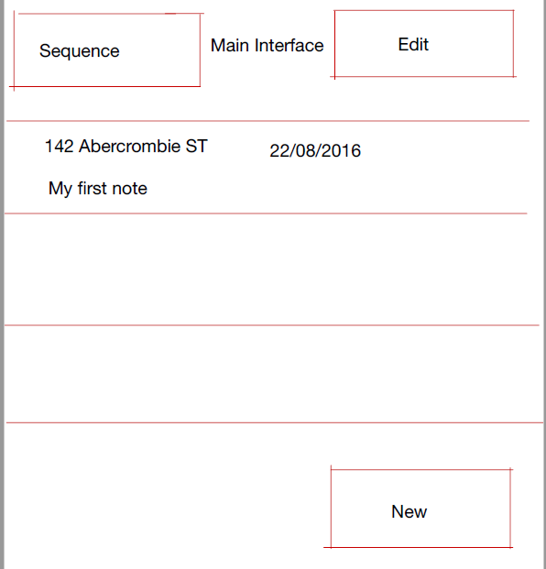

Figure.511

The Main Interface is the first layout that users will see after opening the app. As shown in Figure.511, in this Main Interface layout, there will be one list and three buttons initially. The three buttons are denoted as ‘New’ button, ‘Edit’ button and ‘Sequence’ button. After users clicking on ‘New’ button, the final app will jump to Editing Interface (which will be discussed in layout 3). After clicking on ‘Edit’ button, the final app will jump to Deleting Interface (which will be discussed in layout 2). This project will use widget ‘Button’ with attribute ‘android: onClick’ in Android API to realize this function. [3]

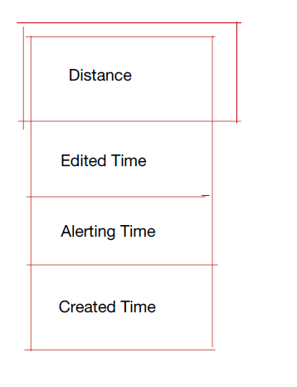

Figure.512

As shown in Figure.512, after clicking on ‘Sequence’ button, users can choose the way of sequencing the notes. The sequence of all of the notes shown in the list will be changed based on the users’ choices. This project will use the method ‘sort’ in ‘jave.util.Collections’ to achieve this goal. [4]

Users’ notes are shown in the list. The list will be displayed with the widget ‘ListView’ in Android API. [5] In this layout, only the abstracts of the notes are shown in the list. The abstract of each note typically contains the user-setting position, editing time and the excerpt of that note. After short clicking on the abstracts of the notes, the final app will jump to the Editing Interface.

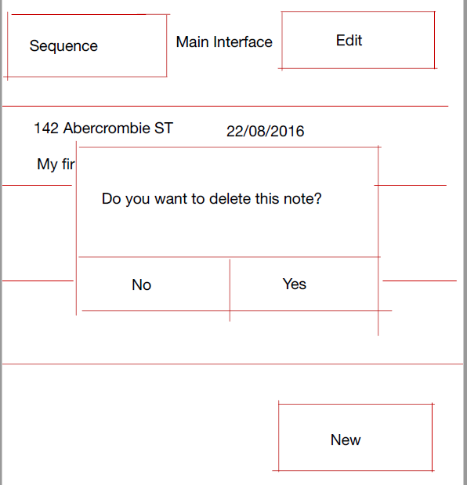

Figure.513

As shown in Figure.513, after long clicking on the abstracts of the notes, the final app will pop up a dialog to ask that if users want to delete this note. The dialog will be built with class ‘android.app.AlertDialog’ in Android API. [6]

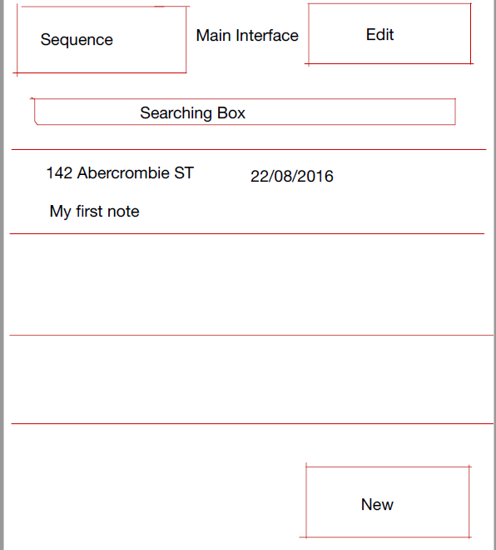

Figure.514

As shown in Figure.514, after users sliding fingers down, the searching box will be shown upon the list. The searching box will be based on the widget ‘SearchView’ in Android API. [7]

## ②Deleting Interface – layout 2

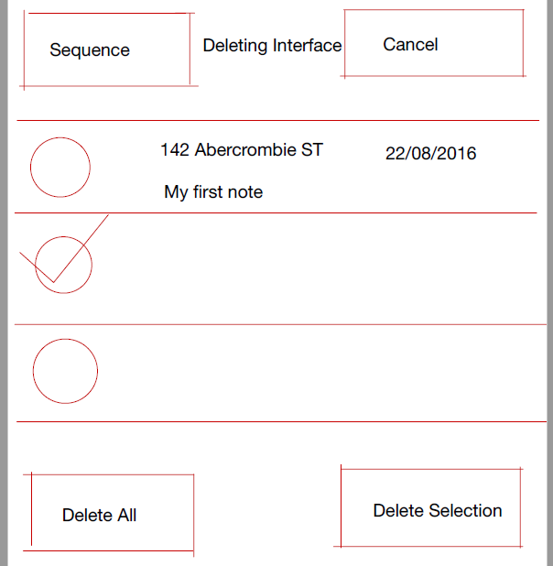

Figure.521

After clicking on ‘Edit’ button in the Main Interface, users will see this Deleting Interface. As shown in Figure.521, in this layout, there will be a list and four buttons. The four buttons are denoted as ‘Delete All’ button, ‘Delete Selection’ button, ‘Cancel’ button and ‘Sequence’ button. The function of ‘Sequence’ button is the same as the function of ‘Sequence’ button in the Main Interface. After users clicking on ‘Cancel’ button, the final app will jump back to the Main Interface without changing anything. After clicking on ‘Delete All’ button, all of the notes displayed on the screen will be deleted. After clicking on ‘’Delete Selection’ button, all of the selected notes will be deleted. There is also CheckBox before each note displayed in the list. The CheckBox is used to check that if users want to select that note. The abstracts of the notes are also shown in the list. This project will use the widget ‘CheckBox’ in Android API to implement this target. [8]

## ③Editing Interface - layout 3

## ④Map Interface – layout 4

# Reference

[1] https://www.any.do/

[2] https://todoist.com/

[3] https://developer.android.com/reference/android/widget/Button.html#

[4] https://developer.android.com/reference/java/util/Collections.html#

[5] <https://developer.android.com/reference/android/widget/ListView.html>

[6] https://developer.android.com/reference/android/app/AlertDialog.html

[7] https://developer.android.com/reference/android/widget/SearchView.html

[8] https://developer.android.com/reference/android/widget/CheckBox.html